Manual for Causes of Death Visualization Tool:

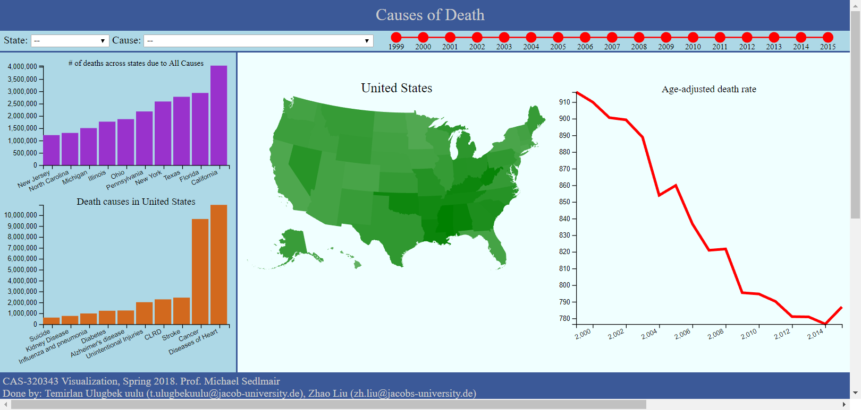

Charts we have from left to right:

Bar charts indicate the top 10 causes of death and top 10 states.

Geo-heatmap indicate which states has higher or lower death rate.

Line chart indicate the trend of death rate, red line is the avg. death rate in US, blue line is the specific state’s death rate.

Filter apply:

State or Causes of death:

You can select specific state or causes of death as filter on the selection area, you can also apply filter by either clicking the bar in bar charts or specific states on the heatmap. Filter will be applied to all three charts.

Year:

You can apply time filter by left click to select the starting year and left click while holding ctrl to select end year.

Hover:

When Hover over, you can see specific numbers of each data entry.